**JUNIPER-CISCO RIP LAB**

**Network Topology:**

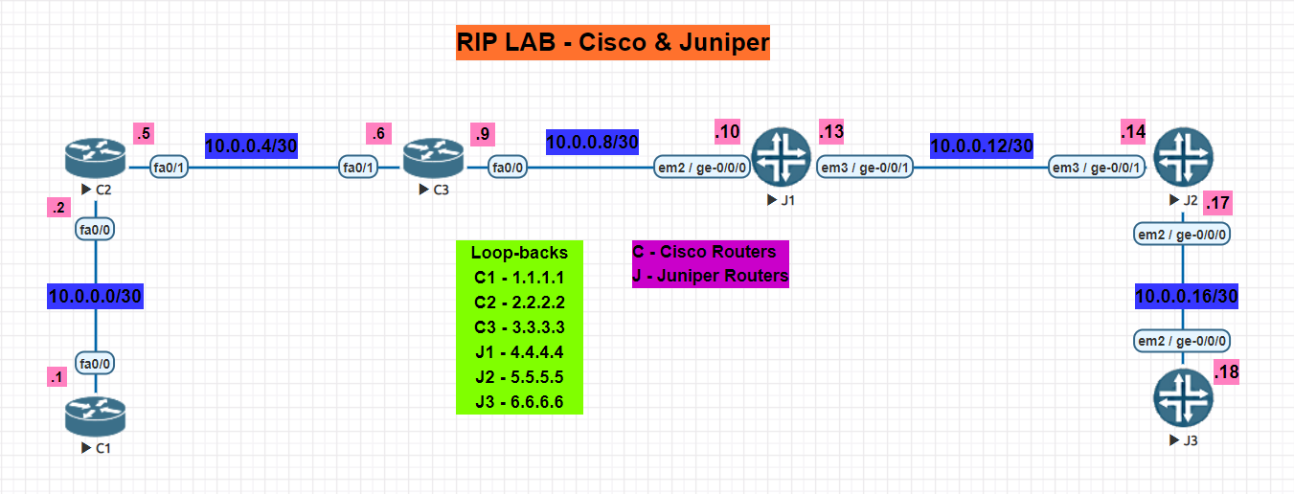

**NOTE: Perform all the basic configuration on Juniper Router given in Juniper Static Routing Lab before performing the lab**

1. **Configure the respective physical interfaces & also configure the loopback interfaces on all the routers in the configuration mode as per the network topology**

**CISCO Routers:**

**C1:**

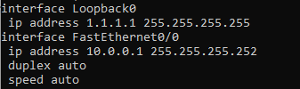

**C2:**

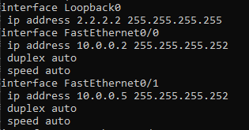

**C3:**

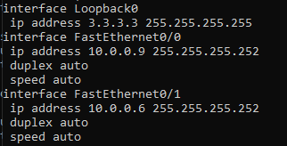

**JUNIPER Routers:**

**J1:**



**J2:**



**J3:**



1. **Verify using the show command that all the interfaces are configured correctly.**

**CISCO Routers:**

**C1:**

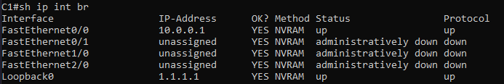

**C2:**

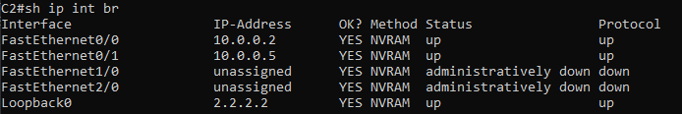

**C3:**

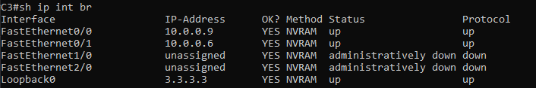

**JUNIPER Routers:**

**J1:**



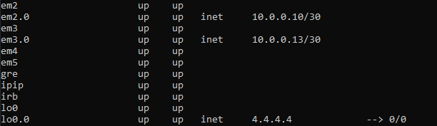

**J2:**



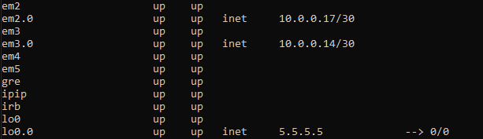

**J3:**



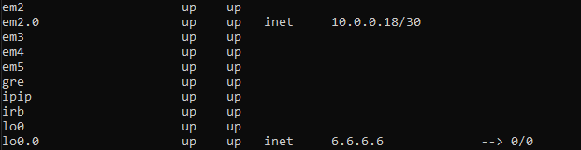

1. **Run RIPv2 protocol on all the Cisco Routers & advertise their respective networks.**

**CISCO Routers:**

**C1:**

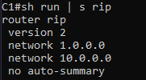

**C2:**

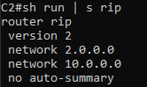

**C3:**

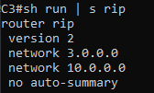

1. **Enable RIP routing protocol on all the Juniper router under the group name ‘rip-juniper’ advertise the interfaces into the rip group name ‘rip-juniper’**

**JUNIPER Routers:**

**J1:**



**J2:**



**J3:**



1. **Create a Routing policy such that it advertises both the direct & RIP learned routes.**

**JUNIPER Routers:**

**J1:**



**J2:**



**J3:**



1. **Now, import & export the routes learnt from RIP**

**JUNIPER Routers:**

**J1:**



**J2:**



**J3:**



1. **Verify using the show command on both the Cisco & Juniper routers whether Routes learnt from RIP is seen or not in the routing table.**

**CISCO Routers:**

**C1:**

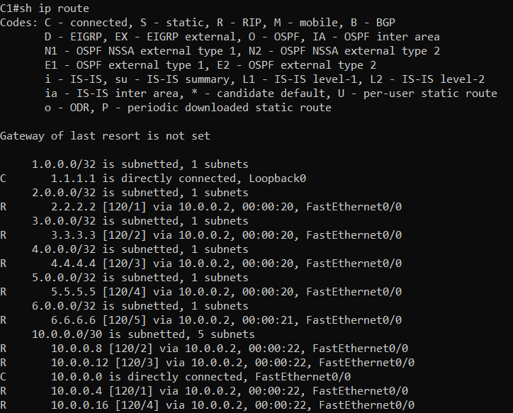

**C2:**

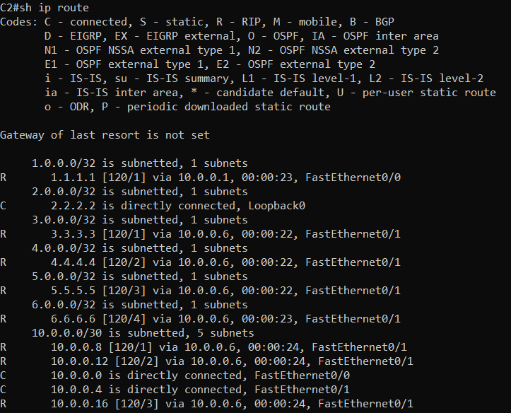

**C3:**

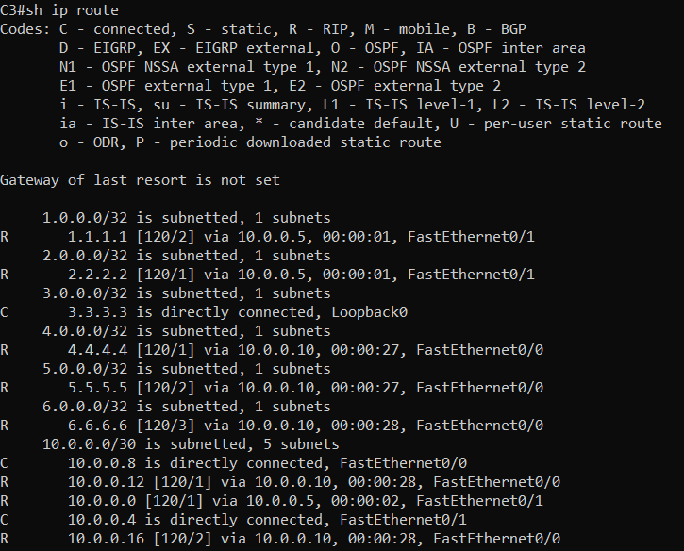

**JUNIPER Routers**

**J1:**

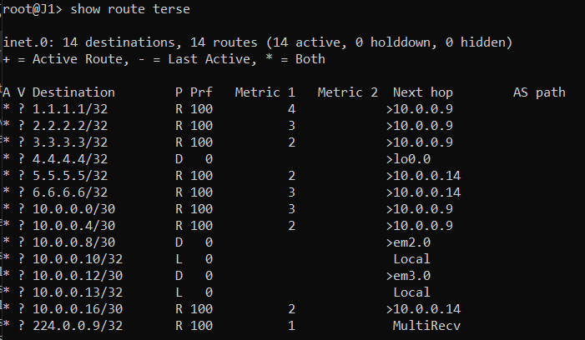

**J2:**

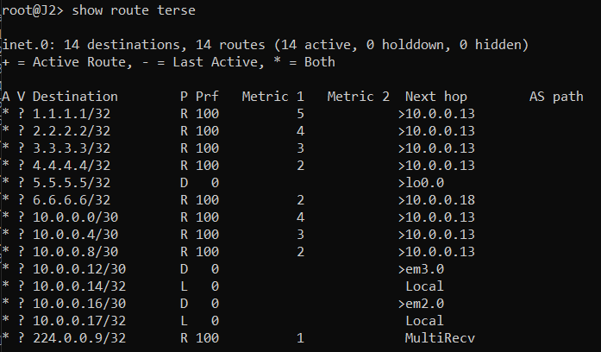

**J3:**

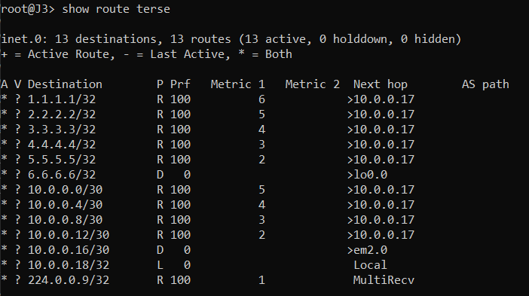

1. **Verify using the ping command & traceroute to check the end to end connectivity from loopback of C1 to loopback of J3**

**Ping:**

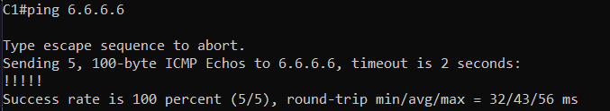

**Traceroute:**

